Becoming a Dog Trainer
By Jerry Bradshaw, Training Director, Tarheel Canine
© 2024 Girard William Bradshaw, All Rights Reserved

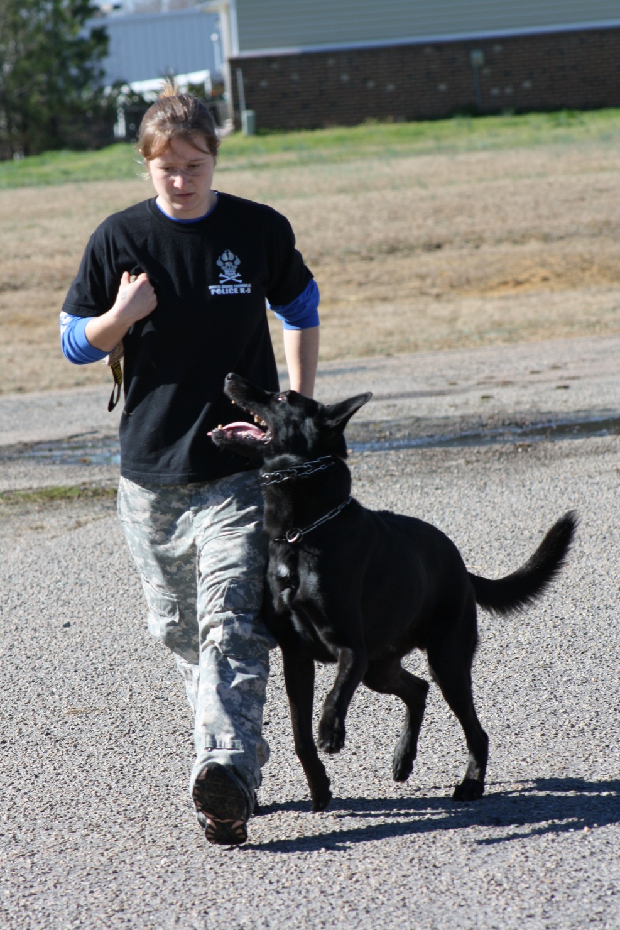

Introduction
The animal field is a growing field. According to the APPMA spending on pet services, including pet training, was around 3 Billion dollars in 2008. By 2018 it was 90 billion, and in 2024 it is estimated to be 150 billion. The pet services industry is strong, even through economic downturns, people continue to spend on their pets. It may not be completely recession proof, but it is certainly showing a significant resistance to stagnation. It is certainly an industry you want to take advantage of.
Training services, including pet obedience training and behavior modification are thriving. As people get pets, they often realize that communicating with them is not as easy as in the movies or cartoons, and the joy of pet ownership can deteriorate into frustration. This is where dog trainers and pet behaviorists come into play. But the question remains, how do you become a dog trainer? The answer is not so simple.
If you look on the internet, and Google “School for Dog Trainers” you will quickly realize that it seems every website promises you the career of a lifetime, and a dream job working with animals. From online schools, to academies you attend, to programs that blend classroom work with short apprenticeships. How do you make the decision on what academy is the one for you?
In many ways, choosing an academy is like choosing a college. You are looking for the right fit. If you are young and have no commitments it may be easier to go to a longer program where you may have to relocate for a while at the school. If you have a job and family responsibilities, you may only have the option to study online, or come to school for a shorter period of time.
In this free e-book, we will look at the different types of training options out there, and what the competitive advantages of each may be, to help you realize your dream of becoming a Professional Dog Trainer.
Consideration 1: Distance Learning or In Residence.
There is absolutely no substitute for hands on learning when it comes to dog training. If you go on the internet, Facebook, and some dog related message boards you will encounter a lot of people who talk a good game about dog training. They may use a lot of dog psychology terminology, and sound very learned, but believe me, it doesn’t mean a thing. I have seen some very impressive articles by trainers who tell you how it “should” be done, but watching them actually work with a dog is an exercise in clumsiness. There is a natural flow to good dog training and good dog trainers have it and can teach it.
Dog training is part science (canine learning theory) and part art (the application of that theory). Every dog reacts to its environment differently. You might read some posts on the internet about “purely positive” training being superior to “aversive” or “punishment training.” Firstly, you cannot “punish” a behavior into existence. That is simply an attempt at framing the debate. You can leverage leash pressure to negatively reinforce a behavior to create it when the dog is not motivated for food or toys, but you cannot punish a behavior into appearing. Purely positive training, in theory, sounds great. You use food or toys to manipulate and reward desired behaviors and withhold rewards when the dog performs incorrectly. The problem is, what happens when the dog doesn’t want to take the food, or doesn’t like playing with toys, or values the display of aggression more than the treats? Here is where theory clashes with reality in dog training. A good dog trainer has a wide range of techniques at his disposal and matches the dog’s temperament to the learning process to which the dog is most suited. You must train the dog in front of you, and not a hypothetical dog. If all you do is learn one way, one theory or approach, you will become very frustrated when you put the theory into action and the dog doesn’t progress as was predicted by the “theory.” This is where the hands on training makes all the difference. Until you have had to change methods, or make adjustments in training to suit a particular dog’s temperament, you won’t really understand how to train dogs. Until you train a dog you don’t have a prior relationship with, that doesn’t live with you already, you wont truly understand how to train dogs.
Online courses which only teach theory are valuable, but don’t base a career on them. You will, at a minimum have to perform some type of internship or learn from a practicing trainer.
Consideration 2: Attend a School for Dog Trainers?
Some websites you may visit, such as the APDT (Association of Pet Dog Trainers) will argue that dog training schools are not appropriate ways to learn to be a trainer. In fact their article “So You Want to be a Dog Trainer?” from their website states: “There are some "dog training schools". As a matter of policy, at this time the APDT cannot endorse any of the selected training programs that are available around the country.” The fact that they put “dog training schools” in quotes is clearly an editorial commentary. The fact is, that organization is just a group of people with a like-minded disdain for anything but purely positive, motivational-only training, and many of us who have been in the business of dog training see that organization as extremist. One of the claims made by purely motivational trainers is that any kind of negative stimulus (read pain) of any kind or intensity in training could possibly traumatize the dog for life. What they fail to explain is what happens if your dog steps on some hot concrete in the summer, or a branch whacks him in the chest while hiking in the woods? Do you really think he will be traumatized for life? People will say all sorts of things to convince you of their extremist position. Reasonably applied training collar corrections, used in proper situations, in context of a training plan, will not traumatize a dog. It’s just not true. Now constant nagging with a training collar, not properly applied, can cause problems. That’s why you need to learn how to use the tools of the dog training trade.
Here are the facts about Schools for Dog Trainers. There are excellent schools and there are just plain bad schools. Sometimes it can be hard to tell the difference. Many schools are run by instructors who are simply trying to make money and have no interest in really preparing you for a career. On the other hand, there are some excellent schools, run by trainers of national caliber that have produced graduates that have gone on to do great things. The way to sort these schools out involves doing some homework.
(1) Compare credentials of the owner of the school, and the trainers. Even if the owner doesn’t do a majority of the instruction, the owner sets the curriculum and expectations of the trainers in their employ. If the owner is busy teaching seminars and at conferences, as a speaker, you know that person is held in high regard.
(2) Read testimonials from attendees of the school, and see what their experience has been to get a feeling for what the atmosphere is like.
(3) Ask to speak to a few of the graduates, if the school refuses to supply names and contact info, you should be suspicious of their ability to help you get the education you need.
(4) Find out what level of hands on training you will get. Remember, you can learn theory from a book, the point of going to a school is to learn the “art” of dog training. If you are required to bring your own dogs only, and there are no dogs supplied by the school, or worse, you cannot interact with the dogs being trained by the school for their clients, what does that say about how confident they are to prepare you to do the same? There is also a big difference between training dogs you have a personal bond with (your own dogs you live with) and training dogs that belong to someone else. Dogs that belong to someone else, will make up all of your future training clients! At Tarheel Canine, for example, you train real police dogs and real pet dogs, and real PPDs, which are slotted to go back to their owners, or be paired with a police officer to work the street. From the minute you come to school you are being taught to do what you will have to do on your own, at the conclusion of your program. The difference is that you will be supervised while in school.
(5) Beware of programs where there is little to no supervision during training, or where there is no structured lecture presentation. There should be a well-defined curriculum including lecture, observation of instructors, and active participation.
(6) If a program says they can prepare you to train police dogs, but they don’t sell any police dogs, or have few references for that, how will you know if you are being taught properly? The school should produce the service they are claiming to teach you to produce. If they train pet dogs for their clients, you should be able to sit in on intakes with the clients and help train the dog, and then sit in on the go-home. You should be able to be present during any group classes or private lessons so you can see how your trainer/mentor deals with problem dogs, problem owners, or both, and how they explain things to the clients. If they train police dogs you should be able to meet the officers in the handler’s courses and see both the good and the bad of the process.
Consideration 3: Just Apprentice under a local Trainer?
Many organizations of dog trainers will tell you to just find a local trainer and apprentice under them rather than spend a lot of money going to a school for trainers. The problem with this is, where will you find the quality of instruction you need? Why would a local trainer teach you their “secrets” so you can compete with them in their own hometown and take their business? It is unrealistic to think you can get a comprehensive education from a local trainer. They may use you to clean kennels, and run errands, but you may not get what you are really after. They may train dogs well, and teach owners how to deal with their pets, but you don’t know if they can teach you to be a trainer. That is a separate skill altogether.
Consideration 4: What “Method” of dog training should I learn?
In the past 10 years, there has developed a huge divide among trainers based on “method.” Some trainers will tell you that the purely motivational approach is the only “right” way to learn. Other trainers will want to teach you a method based only on the use of the e-collar, applying only a negative reinforcement technique. Dogs learn new behaviors through a process of reinforcement: Positive reinforcement or negative reinforcement. In one case you give the dog something he likes for doing a correct behavior (positive reinforcement). In the other instance, you remove an unpleasant stimulus when the dog does something right (negative reinforcement). Here is the secret – Both methods work for teaching new behaviors, in theory. However, some dogs react better to learning positively, and some learn better using some form of negative reinforcement. Both methods have their plusses and minuses (you have to come to school to learn all of the considerations).
Here is another fact: neither method alone is enough to learn to be a complete trainer. For example at Tarheel Canine School for Dog Trainers, for pet dogs especially, we teach motivationally, and then use aversive (corrections from training collars and e-collars) to proof learned behaviors. Learning new things can be stressful, and we believe learning in a positive environment is preferable to learning in a negative environment. This doesn’t mean that e-collar trainers are bad or pure motivational trainers are bad, it just means you can learn a more complete methodology by blending different approaches to reinforcement and punishment. The school you choose should teach a variety of approaches so you have a full kit of method available to you. Motivation is fine until you find a dog that won’t eat food or play with a ball, and doesn’t respond much to praise. E-Collars are great unless the dog is overly sensitive to stress, and teaching with the e-collar causes a cumulative stress response that blocks the dog from learning. For more information, see my article on www.TarheelCanine.com on the progressive use of the E-Collar.
Consideration 5: Cost
Cost is a large factor in determining where to go. Some programs provide loans through loan services, some schools take Veterans Administration Benefits, and some schools finance the programs themselves. If you take out a loan, you have to pay it back. If you finance your education, you can often spread out the expense of school over time. Some of the larger schools, where you may have less one-on-one interaction are the ones that the loan programs qualify for students to borrow for the school. There is always a trade-off. Speak with the owner of the school about your financing options.
Just because a school offers loan programs and/or takes a particular kind of government grant money, don’t settle for a program that meets that requirement but falls short on a number of other ones. Ask schools if they can arrange financing, some schools will self-finance, but you may have to ask about these programs.

Consideration 6: Graduation requirements
Graduation requirements for the program you choose can vary widely. There should be some balance between your practical work during your time in school, and a written exam. Some schools require you to pass a test that involves being evaluated against some kind of organized sport program’s rules such an AKC “Novice” Obedience Routine, or a Schutzhund 1 level of Obedience or Tracking. Often the ability of you to pass the test will depend on the quality of the dog you have to train for the exercises. If your dog is not genetically well-suited to be trained to that kind of standard, you may have to pay more money to come back to more training, in order to pass the test. Ask about the graduation requirements, lest you be surprised once you have already paid your tuition.
Consideration 7: Atmosphere
You should seek a school where you will fit in well. Nothing could be worse than being in a place where you just don’t fit in, or feel comfortable. You should get some sense of that by talking to the owner of the school or the instructors. Do you share a sense of humor with them? Do they make you feel welcome and comfortable? Ask about how they teach things, what their teaching philosophy is, and how they deal with remediation. Ask how they deal with people who might question techniques and methods. Many trainers are very dogmatic, and will give you the “my way or the highway” speeches. Dog training school should allow you to explore techniques, and ask the important question “why?” It is usually the insecure trainer, or one who only understands how to apply a one-dimensional technique that uses evasion, and anger in response to legitimate questions.
If you can, visit the school, stay for a day or two, and see how the instructors interact with the students. Even if you can’t make the trip, ask if it is ok to do so. If the school makes excuses and seems disinclined to have you come out and spend some real training time with them, take that as a red flag. If you do go, you should get a feel for the people, be able to talk to the other students without the staff being in top of you. Watch the style of teaching, and methods of instruction being used. Feel free to ask questions, and you should, as a potential student, be given good clear answers to your questions. You will know if you fit in there. If you don’t feel it, don’t do it. Trust your gut!

Conclusion: A Balanced Approach
Look for a school that teaches a variety of methods, based on the temperament of the dogs’ being trained rather than on the temperament or the theoretical prejudices of the school or trainer. Look for a school with a low student-instructor ratio, that allows for a majority of hands-on work, but still uses lecture to bring the concepts you are applying together in a unified theoretical construct. The school should provide maximum hands on, so you learn the art and application of the theory. Dog training theory is just that, theory. The dogs don’t read the books the trainers and behaviorists write, so you need to learn what to do when the dog doesn’t follow the recipe. Graduation requirements may differ based on the school you go to, but there should be some real goals you have to reach, training dogs for real owners and for real clients like K9 officers or PPD clients. Look for a school where you fit in, as you will you will be spending an extended time there.
If you find these considerations for choosing a school reasonable, we encourage you to look into Tarheel Canine’s School for Dog Trainers at www.TarheelCanine.com. We encourage you to come out and visit, and speak with our graduates. We are not the biggest school out there, but you will get the highest quality education, and as our graduates will tell you, you will be able to put that education to use in a great career in the growing pet services industry.

